|  |  |  |
| --- | --- | --- |
| Description: LogoDescription: KOTM SPOT FLAT RGB | **Newton Moore Senior High School**  **Year 12 Physics ATAR Unit 3 & 4**  **2019**  **Task 3: Experiment 4.1 Validation** | **Result:**  **/ 44** |

|  |  |  |  |
| --- | --- | --- | --- |
| Student’s name: |  | Total marks: | 44 |
| Teacher’s name: | Kevin Lloyd | Weighting: | 5% |
| Assessment type: | Test | Time allocated:  Due date: | Term 1 week 6 |

Going around in circles – Experiment 4.1 Validation Test

(Use diagrams where appropriate)

1. How is the centripetal force provided when using the apparatus in this experiment? (2 Mark)

______________________________________________________________________________________________________________________

1. Explain why the tape in the apparatus must not touch the bottom of the tube. (2 Marks)

________________________________________________________________________________________________________________________________________________________________________________________________________________________________________________

1. Write a valid hypothesis for this experiment (either part A or B). (3 Marks)

________________________________________________________________________________________________________________________________________________________________________________________________________________________________________________________________________________________________________________________________________________________________________

1. What did the slope of the centripetal vs. velocity squared represent? Demonstrate using formula manipulation. (3 Marks)

________________________________________________________________________________________________________________________________________________________________________________________________________________________________________________________________________________________________________________________________________________________________________

1. Does the fact that the string holding the stopper is not exactly horizontal affect the relation between Fc and v? Explain. (3 Marks)

________________________________________________________________________________________________________________________________________________________________________________________________________________________________________________________________________________________________________________________________________________________________________

1. Determine the relation between F and v in terms of the angle between the string and the horizontal. (3 Marks)

____________________________________________________________________________________________________________________________________________________________________________________________________________________________________________________________________________________________________________________________________________________________________________________________________________________________________

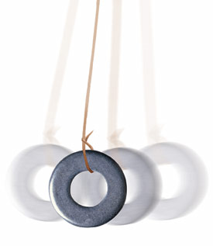

1. The bob of a pendulum swings through a circular arc of constant radius. At what point of the swing does the cord holding the bob exert the greatest centripetal force on the bob? Explain. (3 Marks)

________________________________________________________________________________________________________________________________________________________________________________________________________________________________________________________________________________________________________________________________________________________________________

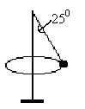

1. In a game of totem tennis, a 0.120 kg ball is moving at a constant velocity in a horizontal circle around the pole as shown. The rope forms an angle of 25.00 to the pole and the horizontal radius of the ball is 1.20 m. The ball takes 0.800 s for one revolution.

1. Draw and label the forces acting on the ball. (2 Marks)
2. What is holding the ball up? (3 Marks)

__________________________________________________________________________________________________________________________________________

1. What is the ball’s acceleration? (2 Marks)

1. What is the tension in the string? (3 Marks)

1. 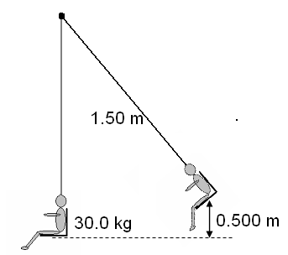A child is sitting on a swing and has been pulled back so that the seat is 0.500 m above the lowest point in the swing. The seat is then released.
2. Calculate the velocity of the swing at its lowest point. (2 Marks)
3. Calculate the tension in the ropes of the swing when a 30.0 kg child is moving through the lowest point in the swing, which has a length of 1.50 m. (3 Marks)
4. A hammer thrower is swinging his 7.25 kg hammer at an angle of 40.00 to the horizontal at a speed of 10.0 ms-1. If the length of his arms are 0.500 m and the length of the wire is 0.700 m, calculate:

The centripetal acceleration. (2 Marks)

The centripetal force. (2 Marks)

The tension in the wire at the top of the swing just as the ball is on the way down.

(3 Marks)

The tension in the wire at the bottom of the swing just as the ball is on the way up. (3 Marks)

END OF VALIDATION